**ORGANIC SHOPPING**

**MINI PROJECT**

**Submitted in partial fulfilment of the requirements for the award of degree of**

**BACHELOR OF COMPUTER APPLICATIONS**

**Of**

**Mahatma Gandhi University**

**Kottayam**

**By**

**GEORGE BENNY(180021092332)**

**SHIBIN THOMAS(180021092346)**



***Department of Computer Applications***

***St. George’s College Aruvithura, Kottayam 686122***

**ST.GEORGE’S COLLEGE ARUVITHURA**



**Department of Computer Applications**

**CERTIFICATE**

This is to certify that the mini project report entitled **“ORGANIC SHOPPING”** is submitted by **GEORGE BENNY(180021092332),SHIBIN THOMAS(180021092346)** in partial fulfilment of the requirements of **Bachelor degree in Computer Applications,** M.G University, during the academic year 2020-2021.

**Project Guide Head of the Department   
Ms.MAREENA GEORGE Ms.BINCY MICHAEL**

**Internal Examiner External Examiner**

**Place: Aruvithura  
Date: ..........................**

**DECLARATION**

I hereby declare that the mini project work entitled “**ORGANIC SHOPPING**” submitted in partial fulfilment of the requirement for the award of Bachelor degree in Computer Applications, is a report of original work done by mean the period of study at St. George’s College, Aruvithura under the supervision of Ms.MAREENA GEORGE.

***GEORGE BENNY(180021092332)***

***SHIBIN THOMAS(180021092346)***

**ACKNOWLEDGEMENT**

It gives me immense pleasure to express heartfelt thanks to all those who helped me in the successful completion of this mini project work. First of all, I would like to thank almighty God who has been a constant support in every walk of my life and the source of strength to complete this project work. I take this opportunity to express my gratitude to all, whose contribution in this project work can never be forgotten.

Words are boundless to express my sincere thanks to **Dr. Reji Varghese Mekkadan, Principal**, St.George’s College Aruvithura for giving me an opportunity for this project.

I express my profound gratitude to **Ms.Bincy Michael**, Head of the department of Computer Applications, for her valuable guidance, timely suggestions and encouragement to complete this project work.

I express heartfelt gratitude to my internal guide **Ms.Mareena George**, for her valuable advice without which the completion of my project would have been impossible.

I wish to express my deep sense of gratitude to my parents and friends for their kind cooperation and moral support. Once again I thank one and all who had helped me directly or indirectly in the successful completion of the project.

Sincerely

***GEORGE BENNY***

***SHIBIN THOMAS***

**TABLE OF CONTENTS**

|  |  |  |
| --- | --- | --- |
| **Chapter No.** | **Title** | **Page No.** |
|  | **ABSTRACT** | 7 |
|  | **LIST OF TABLES** | 8 |
|  | **LIST OF FIGURES** | 9 |
| **1** | **INTRODUCTION** | 10 |
|  | 1.1 PROJECT OVERVIEW | 10 |
|  | 1.2 FEATURES | 11 |
| **2** | **SYSTEM CONFIGURATION** | 12 |
|  | 2.1 HARDWARE SPECIFICATION | 12 |
|  | 2.2 SOFTWARE SPECIFICATION | 12 |
|  | 2.3 SYSTEM SPECIFICATION | 12 |
|  | HTML , CSS , JAVASCRIPT | 14 |
|  | MYSQL SERVER , PHP | 15 |
| **3** | **SYSTEM ANALYSIS** | 17 |
|  | 3.1 PRELIMINARY INVESTIGATION | 17 |
|  | 3.2 EXISTING SYSTEM | 17 |
|  | 3.3 PROPOSED SYSTEM | 18 |
|  | 3.4 FEASIBILITY ANALYSIS | 18 |
|  | 3.5 FEASIBILITY CONSTRAINTS | 19 |
| **4** | **SYSTEM DESIGN** | 22 |
|  | 4.1 INTRODUCTION | 22 |
|  | 4.2 DATA FLOW DIAGRAM | 22 |
|  | 4.3 DATABASE DESIGN | 30 |
| **5** | **CODING AND TESTING PHASE** | 37 |
|  | 5.1 CODING | 37 |
|  | 5.2 SAMPLE CODE | 39 |
|  | 5.3 FORM LAYOUT | 46 |
|  | 5.4 TESTING | 52 |
|  | 5.5 TEST CASES | 56 |
| **6** | **CONCLUSION AND FUTURE SCOPE** | 58 |
|  | 6.1 CONCLUSION | 58 |
|  | 6.2 FUTURE SCOPE | 59 |
| **7** | **BIBLIOGRAPHY** | 59 |

**ABSTRACT**

The proposed system is a website in which sellers can market their products and also they can buy products uploaded by other sellers this website also provide a payment gateway to the sellers. The sellers can reduce the time taken for marketing their products by uploading to this application also the customers can buy good quality products from authorized dealers. Less time for purchasing the products.

The system includes 3 modules. They are:

**Administrator:** Admin must have a login into this system. He has the overall control of the system. Admin can add new categories. Admin can View registered customers and sellers.

**Seller:** Seller can register and they can add their products to the website and they can able to view orders by the customers and process the order. Also they can buy products uploaded by the other sellers.

**Customer:** Customers can register and they can buy products uploaded by the sellers. They can able to manage their account.

**LIST OF TABLES**

|  |  |  |
| --- | --- | --- |
| **Sl. No.** | **Table Name** | **Page No.** |
| **1** | **tbl_cart** | 31 |
| **2** | **tbl_category** | 31 |
| **3** | **tbl_complaints** | 31 |
| **4** | **tbl_customer_delv_address** | 32 |
| **5** | **tbl_customer_order** | 33 |
| **6** | **tbl_delivary** | 33 |
| **7** | **tbl_login** | 34 |
| **8** | **tbl_product** | 34 |
| **9** | **tbl_product_category** | 35 |
| **10** | **tbl_registration** | 35 |
| **11** | **tbl_seller_updated_order** | 36 |
| **12** | **tbl_user_type** | 36 |

**LIST OF FIGURES**

|  |  |  |
| --- | --- | --- |
| **Sl. No.** | **Figure Name** | **Page No.** |
| **1** | **Level 0 DFD** | 23 |
| **2** | **Level 1 DFD** | 24 |
| **3** | **Level 2 DFD of Login** | 26 |
| **4** | **Level 2 DFD of User Management** | 26 |
| **5** | **Level 2 DFD of Manage Category** | 28 |
| **6** | **Level 2 DFD of Manage Item** | 28 |
| **7** | **Level 2 DFD of Manage Order** | 29 |
| **8** | **Level 2 DFD of Manage Complaint** | 29 |
| **9** | **Home Organic Shopping** | 46 |
| **10** | **Registration** | 46 |
| **11** | **Login** | 47 |
| **12** | **Customer Homepage** | 47 |
| **13** | **Products on Customer Homepage** | 48 |
| **14** | **Orders Of Customer** | 48 |
| **15** | **Seller Homepage** | 49 |
| **16** | **Seller products** | 49 |
| **17** | **Seller Add Product Page** | 50 |
| **18** | **Admin Homepage** | 50 |
| **19** | **Admin View Users** | 51 |
| **20** | **Admin Add category Page** | 51 |

**1.INTRODUCTION**

**Organic shopping** is a website which is designed to help the peoples who are interested to do vegetable gardening .By using this website they can able to market their products online. In our locality many home makes are very passionate to vegetable gardening through this website they can make their passion into profit and make it as an income.

The proposed system is a website in which sellers can market their products and also they can buy products uploaded by other sellers this website also provide a payment gateway to the sellers.

* 1. **PROJECT OVERVIEW**

Organic shopping is a website which is designed to help the peoples who are interested to do vegetable gardening .By using this website they can able to market their products online. In our locality many home makes are very passionate to vegetable gardening through this website they can make their passion into profit and make it as an income. The proposed system includes three users they are administrator, customer and seller. Registered customer can view the products and buy products. Sellers can add their products and sell their products .they can view their orders and complaints from the customers. The administrators have the overall control to the system**.**

The following are the activities carried out in the concern.

* A user can search products by name.
* A seller can edit their profile.
* A customer can update details.
* Admin can access all the system functions.
* A user can add reviews and complaints
* A user can add, view, and update their cart.
* A user get reply from the sellers for their questions and doubts.
* A seller can add, view and update products.
* A seller can view, reply to complaints from customers.
* A seller can view orders from customers.
* Admin can view users and sellers and can manage them.

PHP is used as the development tool and MYSQL Server Management Studio as database. The advantages which can be pointed out are operational redundancy, saving of time and user friendliness.

* 1. **FEATURES**
* **Time Saving:** Since this software manage the easy admission of service providers and users can save time.
* **Cost Efficient:** The software can run on systems with basic configuration. Also it can fully restrict the pen and paper usage.
* **Easy Data Access:** Since the information is stored in an organized pattern, data can be easily retrieved.
* **Future Reference:** The well-formatted reports are useful for future references.
* **Efficient:** The “Organic Shopping” is very much effective than the existing manual system.
* **Security:** The new system provide more security from data loss or from malpractices.

1. **SYSTEM CONFIGURATION**

**2.1 HARDWARE SPECIFICATION**

**Processor :** Pentium IV or above / AMD Radeon

**RAM :** 4.00 GB

**Hard Disk :** 1 TB

**2.2 SOFTWARE SPECIFICATION**

**Operating system :** Microsoft Windows 7 or above

**Platform :**Wamp, Xamp

**2.3 SYSTEM SPECIFICATION**

**Front-end :** HTML ,CSS ,JS ,PHP

**Back-end :**MYSQL

**Front-end and back-end selection:**

An important issue for the development of a project is the selection of suitable Front-End and Back-end. When we decided to develop the project we went through an extensive study to determine the most suitable platform that suits the needs of the organization as well as help in development of the project.

The aspects of our study included the following factors.

**Front-end selection**:

It must have a graphical user interface what assists users that are not from IT background

1. Scalability and extensibility
2. Flexibility
3. Robustness
4. Platform independent.
5. Easy to debug and maintain.
6. Event driven programming facility.
7. Front end must support some popular back end like MYSQL or MS Access.

According to the above stated features we selected PHP as the front-end for developing our project

**Back-end selection:**

1. Multiple user support.
2. Efficient data handling.
3. Provide internet features for security.
4. Efficient data retrieval and maintenance.
5. Stored procedure.
6. Operating System compatible.
7. Easy to install.
8. Easy to implant with the Front-end.

According to above stated features we selected MYSQL as the backend. The technical feasibility is frequently the most difficult area encountered at this stage. It is essential that the process of analysis and definition be conducted in parallel with an assessment to technical feasibility .It centers on the existing computer system (Hardware, software etc.) And to what extend it can support the proposed system.

**HTML ,CSS ,JAVASCRIPT**

HTML or (Hyper Text Mark-up Language) is a programming language used to create web pages, along with Cascading Style Sheets (CSS), and JavaScript. It is a cornerstone technology used to create web pages. The basic idea behind CSS is to separate the structure of a document from presentation of the document. HTML is meant for structure .It was never intended for anything else. All those attributes you add to style your page were added later as viewing public demanded it .All those addition through make HTML clumsy and work against its main purpose of structuring a document .HTML is there to let a browser know that this block of text is a paragraph and that block of text is a heading for this paragraph.

Java script is one of the most simple, versatile and effective languages used to extend functionality in websites. Uses range from on screen visual effects to processing and calculating data on web pages with ease as well as extended functionality to websites using third party scripts among several other handy features, however it also possesses some negative effects that might make you want to think twice before implementing Java script on your website.

**MYSQL SERVER**

MySQL is an open source relational database management system (RDBMS) based on Structured Query Language (SQL).MySQL runs on virtually all platforms, including Linux, UNIX, and Windows. Although it can be used in a wide range of applications, MySQL is most often associated with web-based applications and online publishing and is an important component of an open source enterprise stack called LAMP. LAMP is a Web development platform that uses Linux as the operating system, Apache as the Web server, MySQL as the relational database management system and PHP as the object-oriented scripting language. (Sometimes Perl or Python is used instead of PHP.) MySQL, which was originally conceived by the Swedish company MySQL AB, was acquired by Sun Microsystems in 2008 and then by Oracle when it bought Sun in 2010. Developers can still use MySQL under the GNU General Public License (GPL), but enterprises must obtain a commercial license from Oracle.

Offshoots of MySQL are called forks. They include:.

MariaDB – a popular community-developed "drop-in" replacement for MySQL that uses MySQL APIs and commands.

Percona Server with XtraDB– an enhanced version of MySQL known for horizontal scalability.

MySQL is a free-to-use, open-source database that facilitates effective management of databases by connecting them to the software. It is a stable, reliable and powerful solution

**PHP**

PHP  is a general-purpose programming language originally designed for web development. It was originally created by Rasmus Lerdorf  in 1994. The PHP reference implementation is now produced by The PHP Group. PHP originally stood for *Personal Home Page*, but it now stands for the recursive initialism  *PHP: Hypertext Preprocessor*.

PHP code may be executed with a command line interface (CLI), embedded into HTML code, or used in combination with various web template systems, web content management systems, and web frameworks. PHP code is usually processed by a PHP interpreter implemented as a module in a web server or as a Common Gateway Interface (CGI) executable. The web server outputs the results of the interpreted and executed PHP code, which may be any type of data, such as generated HTML code or binary image data. PHP can be used for many programming tasks outside of the web context, such as standalone graphical applicationsand robotic drone control.

The standard PHP interpreter, powered by the Zend Engine, is free software released under the PHP License. PHP has been widely ported and can be deployed on most web servers on almost every operating system and platform, free of charge.

The PHP language evolved without a written formal specification or standard until 2014, with the original implementation acting as the *de facto* standard which other implementations aimed to follow. Since 2014, work has gone on to create a formal PHP specification.

The fact that PHP was not originally designed, but instead was developed organically has led to inconsistent naming of functions and inconsistent ordering of their parameters.

**3. SYSTEM ANALYSIS**

System analysis as a problem solving technique that break down a system into its component pieces for the purpose of the studying how well those component parts work and interact to accomplish their purpose. It is used in every field where something is developed in order to become familiar with the organization environment and physical process related to the proposed system

**3.1 PRELIMINARY INVESTIGATION**

Preliminary investigation is a problem to solve activity that requires interactive communication between the system users and system developer. It does various feasibility studies. In these studies, a rough figure of system activities can be obtained from the decision and about the strategies to be followed for effective system study and analysis can be taken.

In the preliminary investigation, an initial picture about the system working is obtained from this study and data collection methods are identified. The most critical phase of managing system projects is planning. To launch a system investigation, we need a master plan specifying the steps to be taken, the people to be questioned and the outcome to be expected. The scope of preliminary investigation may vary from a brief one person effort to an extensive series of activities requiring the participation of many individuals.

**3.2 EXISTING SYSTEM**

Many irregularities exit in the existing system. The existing system is a manual system. The systems have many limitations and difficulties. It is time consuming and their no customer and seller interaction. All the process are automated and seller can able to manage their stock using the website efficiently.

**DISADVANTAGES OF EXISTING SYSTEM**

1. Online booking is not possible.
2. There is no seller and customer interaction.
3. Human effort is needed.

**3.3 PROPOSED SYSTEM**

The proposed system is defined to meets all the disadvantages of the existing system. It is necessary to have a system that is more user friendly and user attractive for business growth; on such consideration the system is proposed. In our proposed system there is admin who can view all the sellers and customers. The sellers can register the website and they can market their products online and sell it. The customers will get the exact details of the products and delivers get the products within one hour of booking.

We have selected HTML,CSS,JS and PHP as front end and MySQL as backend for developing this project. PHP provides user friendly environment and MySQL server satisfies high accuracy.

**ADVANTAGES OF PROPOSED SYSTEM**

1. Better security.
2. Better service.
3. High performance
4. Easy to use

**3.4 FEASIBILITY ANALYSIS**

Feasibility analysis is a test of system proposed according to work ability, impact of the organization and effective uses of resources. It also evaluates the resources. It evaluate the existing systems and it is a procedure to develop a candidate systems which are suitable to solve the problem. A feasibility test finds answer to the following questions.

* What are the needs of the user?
* How the candidate systems meet the needs?
* Whatever the problem is worth solving?
* What are the resources available?
* How the system works in the proposed organization?

**3.5 FEASIBILTY CONSTRAINTS**

1. **Economic Feasibility**

Economic feasibility attempts to weigh the cost of developing and implementing a new system, against the benefits that would accrue from having the new system in place. This feasibility study gives the top management the economic justification for the new system. A simple economic analysis which gives the actual comparison of costs and benefits are much more meaningful in this case. In addition, this proves to be a useful point of reference to compare actual costs as the project progresses. There could be various types of intangible benefits on account of automation. These could include increased user satisfaction, improvement in quality better decision making timeliness of information, expediting activities, improved accuracy of operations, better documentation and record keeping, faster retrieval of information.

If benefits outweigh costs then the decision is made to design and implement the system. The proposed system is more economic than the existing system, since it uses GUI that the chance of error is low and cost needed to correct the error is reduced. In the new system the experience is only met at the time of initial installation and hence the proposed system is considered to be economically feasible.

1. **Technical Feasibility**

A study of the resource availability that may affect the ability to achieve an acceptable system. The evaluation determines whether the technology needed for the proposed system is available or not. Evaluating the technical feasibility is the trickiest part of a feasibility study. This is because, at this point in time, not too many detailed design of the system, making it difficult to access issues like performance, costs (on account of the kind of technology to be deployed) etc.

A number of issues have to be considered while doing a technical analysis.

* Can the work for the project be done with current equipment existing software technology and available personal?
* Can the system be upgraded if developed?
* If the new technology is needed then what can be developed?

This is the concerned with specifying equipment and software that will successfully satisfy the user requirement.

1. **Operational-Feasibility**

Proposed project is beneficial only if it can be turned into information systems that will meet the organizations operating requirements. Simply stated, this test of feasibility asks if the system will work when it is developed and installed?, Are there major barriers to Implementation? Here are questions that will help test the operational feasibility of a project. Is there sufficient support for the project from management from users? If the current system is well liked and used to the extent that persons will not be able to see reasons for change, there may be resistance.

Are the current business methods acceptable to the user? If they are not, Users may welcome a change that will bring about a more operational and useful systems.  
Have the user been involved in the planning and development of the project?   
Early involvement reduces the chances of resistance to the system and in general and increases the likelihood of successful project.

Since the proposed system was to help reduce the hardships encountered in the existing manual system, the new system was considered to be operational feasible.

1. **Behaviour Feasibility**

It includes how strong the reaction of user will be towards the development of new system that involves computer’s use in their daily work. So resistant to change is identified. An estimate should be made of how strong a reaction the user is likely to have toward the development of a computerized system. It deals with the whole behaviour of the system.

**4. SYSTEM DESIGN**

**4.1 INTRODUCTION**

The design phase focuses on the detailed implementation of the system recommended in the feasibility study. Emphasis is on translating performance specification into design specification. The design phase is a transition from a user- oriented document to a document oriented to the programmers or data base administrator.

In the design phase of Organic Shopping, the solution to the identified problems in the feasibility analysis are extracted. A new system with all necessary modules required to manage the entire allotment operations. It also involves the creative design of the database.

**4.2 DATA FLOW DIAGRAM (DFD)**

A data flow diagram is the best and easiest tool to represent the flow of the data in the project. It is otherwise known as bubble chart. It has the purpose of clarifying system requirements and identifying major transformations that will become programs in the system design. It is the major starting point in the design phase that functionally decomposes the requirements specifications down to the lowest level of detail. A DFD consists of a series of bubbles joined by lines. The bubble represents data flow in the system.

In the normal convention a DFD has four major symbols.

1. A Square defines source or destination of data.
2. An Arrow shows data flow.
3. A Circle or oval represents a process that transforms incoming data into outgoing data flows
4. An Open rectangle shows a data store

**DATA FLOW DIAGRAM OF THIS PROJECT**

**LEVEL 0 DFD :**

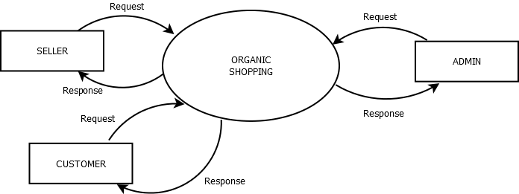

**LEVEL 1 DFD :**

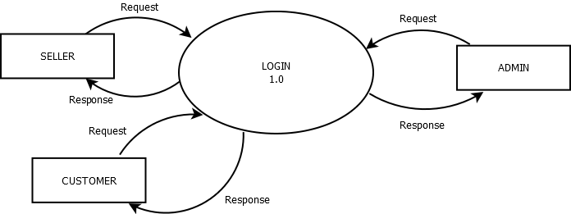

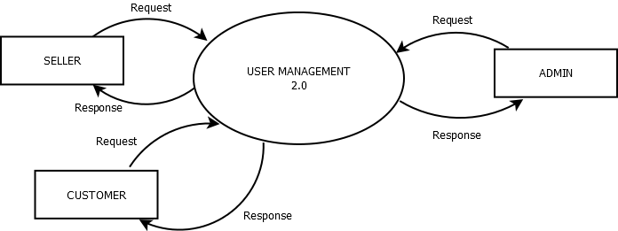

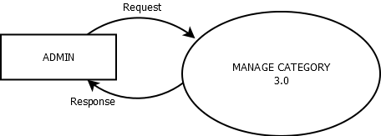

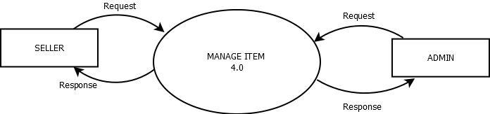

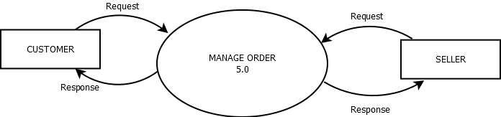

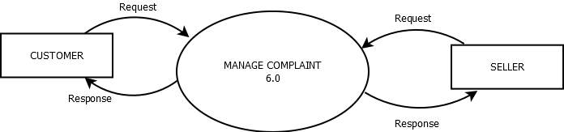

**LEVEL 2 DFD :LOGIN**

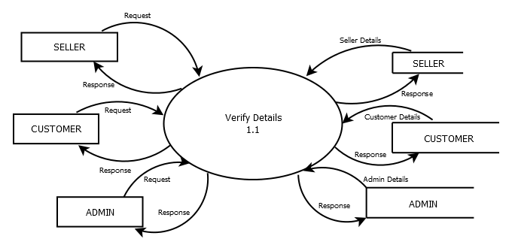

**LEVEL 2 DFD:USER MANAGEMENT**

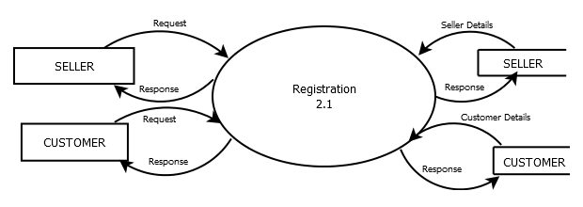

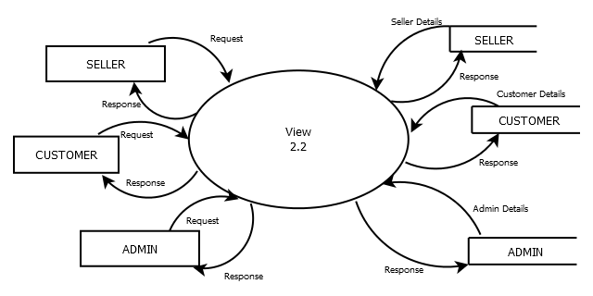

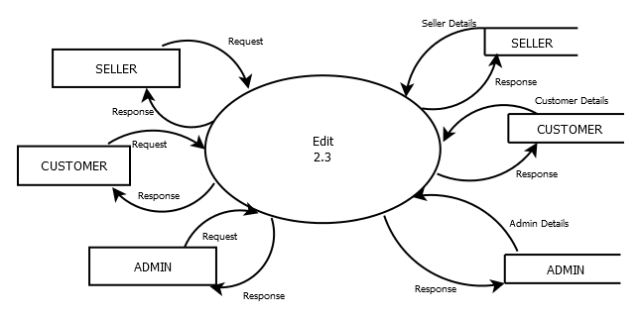

**LEVEL 2 DFD : MANAGE CATEGORY**

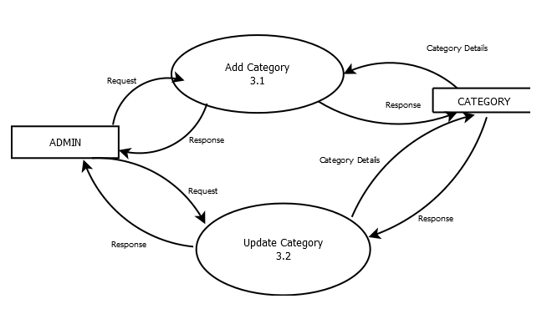

**LEVEL 2 DFD: MANAGE ITEM**

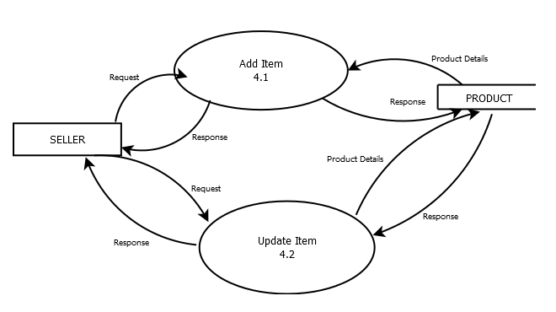

**LEVEL 2 DFD: MANAGE ORDER**

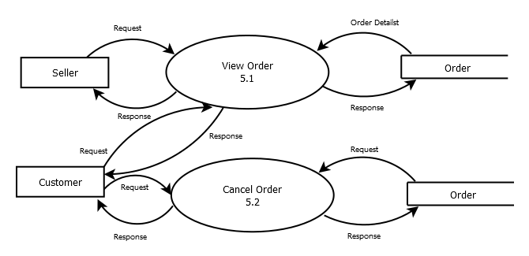

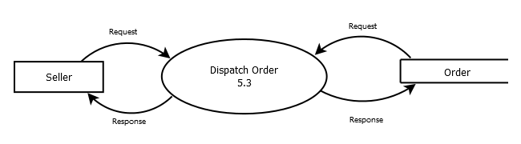

**LEVEL 2 DFD: MANAGE COMPLAINT**

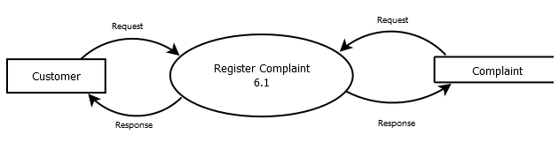

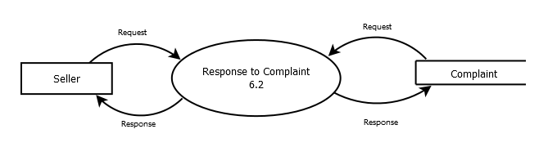

**4.3 DATABASE DESIGN**

The primary objective of a database design are fast response time to inquiries, more information at low cost, control of redundancy, clarity and ease of use, accuracy and integrity of the system fast recovery and availability of powerful end-user language.

The database design is a two level process. In the first step, user requirements are gathered together and a database is designed which will meet these requirements as clearly as possible. This step is called Information Level Design and it is taken independent of any individual DBMS.

In the second step, this Information level design is transferred into a design for the specific DBMS that will be used to implement the system in question. This step is called Physical Level Design, concerned with the characteristics of the specific DBMS that will be used. A database design runs parallel with the system design. The organization of the data in the database is aimed to achieve the following two major objectives.

* Data Integrity

-

* Data independence

**4.4 TABLE DESIGN**

**TABLE - 1: tbl_cart**

|  |  |  |  |
| --- | --- | --- | --- |
| **FIELD** | **DATA TYPE** | **CONSTRAINT** | **DESCRIPTION** |
| caid | int | Not Null,  AUTO_INCREMENT | Cart product id |
| email | varchar(255) | Not Null | Email address |
| product_category_id | int | Not Null | Category id of product |
| qunty | varchar(255) | Not Null | Quantity of product in cart |
| amount | varchar(255) | Not Null | Amount of product |

**TABLE -2: tbl_category**

|  |  |  |  |
| --- | --- | --- | --- |
| **FIELD** | **DATA TYPE** | **CONSTRAINT** | **DESCRIPTION** |
| catid | int | Not Null,  AUTO_INCREMENT | Category id |
| category | Varchar(255) | Not Null | Category name |
| status | varchar(255) | Not Null | Status of the category |

**TABLE -3: tbl_complaints**

|  |  |  |  |
| --- | --- | --- | --- |
| **FIELD** | **DATA TYPE** | **CONSTRAINT** | **DESCRIPTION** |
| complaints_id | int | Not null | Id of the complaint |
| email | varchar(255) | Not null | Email Id of the person complained |
| customer_order | int | Not null | Order of the customer |
| stock_product_id | int | Not null | Stock Product id |
| complaint_message | varchar(255) | Not null | Complaint message from user |
| reply_message | varchar(255) | Not null | Reply message from seller |
| status | varchar(255) | Not null | Status of the complaint |

**TABLE -4: tbl_customer_delv_address**

|  |  |  |  |
| --- | --- | --- | --- |
| **FIELD** | **DATA TYPE** | **CONSTRAINT** | **DESCRIPTION** |
| delv_adres_id | int | Not null | Delivery Address |
| email | varchar(255) | Not null | Email Address of the customer |
| fname | varchar(255) | Not null | Name of customer |
| Mobile number | varchar(255) | Not null | Mobile number of the customer |
| address_line | varchar(255) | Not null | Address of the customer |
| landmark | varchar(255) | Not null | Landmark of the customer address |
| town_city | varchar(255) | Not null | Town city of the customer address |
| pin_code | varchar(255) | Not null | Pin Code of the customer |
| address_type | varchar(255) | Not null | Type of Address of the customer |
| status | varchar(255) | Not null | Status of the delivery Address |

**TABLE -5: tbl_customer_order**

|  |  |  |  |
| --- | --- | --- | --- |
| **FIELD** | **DATA TYPE** | **CONSTRAINT** | **DESCRIPTION** |
| customer_order_id | int | Not null | Order id |
| email | varchar(255) | Not null | Email Address of the customer |
| stock_product_id | Int | Not null | Stock product id |
| delv_adres_id | Int | Not null | Id of delivery address |
| purchase_qty | int | Not null | Quantity of purchased product |
| purchase_price | decimal(10,0) | Not null | Price of product |
| order_date | datetime | Not null | Date of order |
| delivery_date | date | Not null | Date of delivery |
| status | varchat(255) | Not null | Status of order |

**TABLE 6: tbl_delivary**

|  |  |  |  |
| --- | --- | --- | --- |
| **FIELD** | **DATA TYPE** | **CONSTRAINT** | **DESCRIPTION** |
| did | int | Not null | delivery id |
| named | varchar(10) | Not null | name |
| email1 | varchar(10) | Not null | email address |
| address | text | Not null | Address of delivery |
| city | varchar(10) | Not null | city of delivery |
| state | varchar(10) | Not null | state of delivery |
| zip | int | Not null | zip code of delivery |
| status | varchar(10) | Not null | status |

**TABLE 7: tbl_login**

|  |  |  |  |
| --- | --- | --- | --- |
| **FIELD** | **DATA TYPE** | **CONSTRAINT** | **DESCRIPTION** |
| email | varchar(30) | Not null | email used for login |
| user_type_id | int | Not null | type of user |
| password | varchar(30) | Not null | password for login |
| status | varchar(10) | Not null | status of login |

**TABLE 8:tbl_product**

|  |  |  |  |
| --- | --- | --- | --- |
| **FIELD** | **DATA TYPE** | **CONSTRAINT** | **DESCRIPTION** |
| pid | int | Not null, Primary Key | product id |
| rid | int | Not null | rid of product |
| product_category_id | int | Not null | category id of product |
| name | varchar(20) | Not null | Product name |
| price | varchar(20) | Not null | Price of Product |
| des | text | Not null | Description of product |
| qunty | float | Not null | Quantity of product |
| date | date | Not null | Date of product |
| image | varchar(20) | Not null | Image of the product |
| picStatus | int | Not null | Status of image |

**TABLE 9: tbl_product_category**

|  |  |  |  |
| --- | --- | --- | --- |
| **FIELD** | **DATA TYPE** | **CONSTRAINT** | **DESCRIPTION** |
| product_category_id | int | Not null, Primary Key, Auto Increment | Category id of Products |
| prod_category_name | varchar(20) | Not null | Category Name of products |

**TABLE 10: tbl_registration**

|  |  |  |  |
| --- | --- | --- | --- |
| **FIELD** | **DATA TYPE** | **CONSTRAINT** | **DESCRIPTION** |
| rid | int | Not null, Primary Key, Auto Increment | rid of table |
| fname | varchar(20) | Not null | First name of user |
| lname | varchar(20) | Not null | Last name of user |
| phone_no | varchar(15) | Not null | Phone number of user |
| email | varchar(30) | Not null, foreign key | Email id of user |
| place | varchar(30) | Not null | Place of user |
| images | varchar(10) | Not null | Image of the user |

**TABLE 11: tbl_seller_updated_order**

|  |  |  |  |
| --- | --- | --- | --- |
| **FIELD** | **DATA TYPE** | **CONSTRAINT** | **DESCRIPTION** |
| updated_order_id | int | Not null, Primary Key, Auto Increment | Updated order id |
| customer_order_id | int | Not null, foreign key | Customer order id |
| email | varchar(20) | Not null, foreign key | Email address |
| deliver_on | datetime | Not null | Delivery date |
| additional_cost | decimal(10,0) | Not null | Additional cost of order |
| dispatched_date | datetime | Not null | Date of which product is dispatched |
| status | varchar(15) | Not null | status of updated order |

**TABLE 12: tbl_user_type**

|  |  |  |  |
| --- | --- | --- | --- |
| **FIELD** | **DATA TYPE** | **CONSTRAINT** | **DESCRIPTION** |
| user_type_id | int | Not null, Primary Key, Auto Increment | id of User type |
| user_type_name | varchar(20) | Not null | Type of User |
| status | varchar(10) | Not null | status of user type |

**5. CODING AND TESTING PHASE**

**5.1 CODING**

Coding is a list of step-by-step instructions that get computers to do what you want them to do. This step is also called programming phase. The performance of software design starts by using program code with appropriate programming language and developing error free executable programs in efficient manner. Coding is undertaken once the design phase is complete and the design documents have been successfully reviewed .Computer Coding is term used for writing codes & executing it for getting desired output. In this phase, every module identified and specified in the design document is independently coded and unit tested.

• The input to the coding phase is the design document.

• During the coding phase, various modules identified in the design document are coded according to the respective module specifications. In this phase, each module identified and specified in the design document is independently coded and unit tested.

• A coding standard gives a regular form to the codes written by different engineers.

• It provides sound understanding of the code

• It encourages good programming practice.

**5.1.1 Selection of Programming Language, Operating System**

Coding is an important part of programming paradigm for software development. It is mainly used to develop apps, websites and software. The programming language contains project planning, analysis, design, coding, testing and maintenance. All the above requirements are considered the programming language for “Database Development for Spice Compounds”. It is developed using tools such as Python within the Ubuntu 14.04 platform, Flask Framework for python (Web development). And the MySQL is used as the back end.

Ubuntu Linux is a computer operating system based on the Debian GNU/Linux distribution. It is a free and open source operating system for PC. It is powered by Linux and strong technology operates millions of servers worldwide. Ubuntu 14.04 is faster, more stable and overall much better than 12.04.

In high-level programming languages, python provide strong priority on readability and efficiency, and is mainly compared to other languages like Java, PHP, or C++.Python can be used to build server-side web applications. It is designed to be highly readable. In web programming python working with multiple types of servers, databases and web frameworks for the development of web applications. Python is also used for the representation of chemical structure with openbabel. Openbabel is a chemical toolbox used to represent chemical data.

Flask is a micro-framework and is suitable for small-scale applications. Flask has contained more features than other frameworks. It consists of features like unit testing and built-in development server that allow to create reliable and efficient web applications.

**5.2 SAMPLE CODE**

**PHP code for Database connection**

<?php

$servername="localhost";

$username="root";

$password="";

$db="organic_shop_db";

$con= mysqli_connect($servername,$username,$password,$db);

if(!$con){

die("connection failed:" . mysqli_connect_error());

}

?>

**PHP code for Home page**

<?php

session_start();

if(!isset($_SESSION['sess']))

{

header("location:../index.php");

}

include "../dbcontroller.php";

$m=$_GET['b'];

$bid=$_GET['c'];

$amount=$_GET['d'];

$user=$_SESSION['sess'];

$sql="select * from tournament where id='$m'";

$exe=mysqli_query($con,$sql);

$exe2=mysqli_fetch_array($exe);

$cor=$exe2['Username'];

$tyu=mysqli_query($con,"select * from user_details where Username='$cor'");

$rec2=mysqli_fetch_array($tyu);

$recipient=$rec2['user_id'];

$tyu2=mysqli_query($con,"select * from bank where user_id='$recipient'");

$ba=mysqli_fetch_array($tyu2);

$balan=$ba['balance'];

$credit=$balan+$amount;

$sql4=mysqli_query($con,"select * from user_details where Username='$user'");

$exe4=mysqli_fetch_array($sql4);

$mail=$exe4['email'];

$ide=$exe4['user_id'];

$date=time();

if(isset($_POST['submit'])){

$otp=md5($_POST['otp']);

$ch=mysqli_query($con,"select * from bank where otp='$otp' and bank_id='$bid'");

$ch2=mysqli_fetch_array($ch);

$balance=$ch2['balance'];

$debit=$balance-$amount;

$count=mysqli_num_rows($ch);

if($count==1){

if($balance>0){

$qw=mysqli_query($con,"update bank set otp='0' where bank_id='$bid'");

$qw2=mysqli_query($con,"update bank set balance='$debit' where bank_id='$bid'");

$qw3=mysqli_query($con,"update bank set balance='$credit' where user_id='$recipient'");

$qw4=mysqli_query($con,"insert into application(tour_id,Username,status)values('$m','$user','1')");

$qw5=mysqli_query($con,"insert into payment(match_id,sender,recepient,date,status)values('$m','$ide','$recipient','$date','1')");

header('location:success.php');

}else{ ?>

<div class="alert alert-danger" style="background-color:#E93535;color:white;font-size:18px">

<center><strong>Payment Failed! </strong> Insufficient balance.</center>

</div>

<?php }

}

else{ ?>

<div class="alert alert-danger" style="background-color:#E93535;color:white;font-size:18px">

<center><strong>Payment Failed! </strong> Invalid OTP.</center>

</div>

<?php }

}

?>

<!DOCTYPE html>

<html>

<head>

<meta charset="utf-8" />

<title>Credit Card Payment Form Template | PrepBootstrap</title>

<meta name="viewport" content="width=device-width, initial-scale=1.0" />

<link rel="stylesheet" type="text/css" href="bootstrap/css/bootstrap.min.css" />

<link rel="stylesheet" type="text/css" href="font-awesome/css/font-awesome.min.css" />

<script src="http://code.jquery.com/jquery-1.11.1.min.js"></script>

<link href="http://www.jqueryscript.net/css/jquerysctipttop.css" rel="stylesheet" type="text/css">

<script src="js/3dslider.js"></script>

<script src="js/jquery-2.1.1.min.js"></script>

<script type="text/javascript" src="js/jquery-1.10.2.min.js"></script>

<script type="text/javascript" src="bootstrap/js/bootstrap.min.js"></script>

</head>

<body>

<div class="container">

<div class="page-header">

<center><h1><b>TORNEO</b></h1></center>

</div>

<!-- Credit Card Payment Form - START -->

<div class="container">

<div class="row">

<div class="col-xs-12 col-md-4 col-md-offset-4">

<div class="panel panel-default">

<div class="panel-heading">

<div class="row">

<h3 class="text-center">Payment</h3>

<img class="img-responsive cc-img" src="http://www.prepbootstrap.com/Content/images/shared/misc/creditcardicons.png">

</div>

</div>

<div class="panel-body">

<form role="form" method="post">

<div class="row">

<div class="col-xs-12">

<div class="form-group">

<p style="color:green"> The OTP has been sent successfully to your registered mail ( <?php echo $mail; ?> ).</p>

Please enter the OTP in the field below to verify.

</div>

</div>

</div>

<div class="row">

<div class="col-xs-12">

<div class="form-group">

<label>OTP</label>

<input type="password" name="otp" class="form-control" />

</div>

</div>

</div>

<div class="panel-footer">

<div class="row">

<div class="col-xs-14">

<input type="submit" name="submit" value="PROCEED" class="btn btn-warning btn-lg btn-block">

</div>

</div>

</div>

</form>

</div>

</div>

</div>

</div>

</div>

<style>

.cc-img {

margin: 0 auto;

}

</style>

<!-- Credit Card Payment Form - END -->

</div>

</body>

</html>

**PHP Code for Adding products to Cart**

<?php

session_start();

$mail=$_SESSION['alogin'];

//$pname=$_SESSION['name'];

//$id=$_GET["id"];

$id=$_SESSION['pid'];

?>

<?php

$con=mysqli_connect("localhost","root","","organic_shop_db")or die ("Couldnt connect");

$viewbrand="Select * from tbl_product where alogin=$mail ";

//$viewbrand="Select * from tbl_product where name=$pname ORDER BY name ASC";

$d_seller_brand=mysqli_query($con,$viewbrand);

$rowp=mysqli_fetch_array($d_seller_brand);

$rd=$rowp['mail'];

$product_category=$rowp['product_category_id'];

$price=(int)$rowp['price'];

$cart_item_qty=(int)$_POST['qt'];

$cart_total=$cart_item_qty*$price;

$q_ins1="insert into tbl_cart(mail,product_category_id,qunty,amount)values($rd,$product_category,$cart_item_qty,$cart_total)";

$ins=mysqli_query($con,$q_ins1);

if($ins)

{ echo "<script type='text/javascript'>

alert('New product added successfully');

window.location='cart_view.php';

</script>";

}

else

{

echo "<script type='text/javascript'>

alert('Failed');

window.location='view_single.php';

</script>";

}

?>

**5.3 FORM LAYOUT**

**1.HOME PAGE**

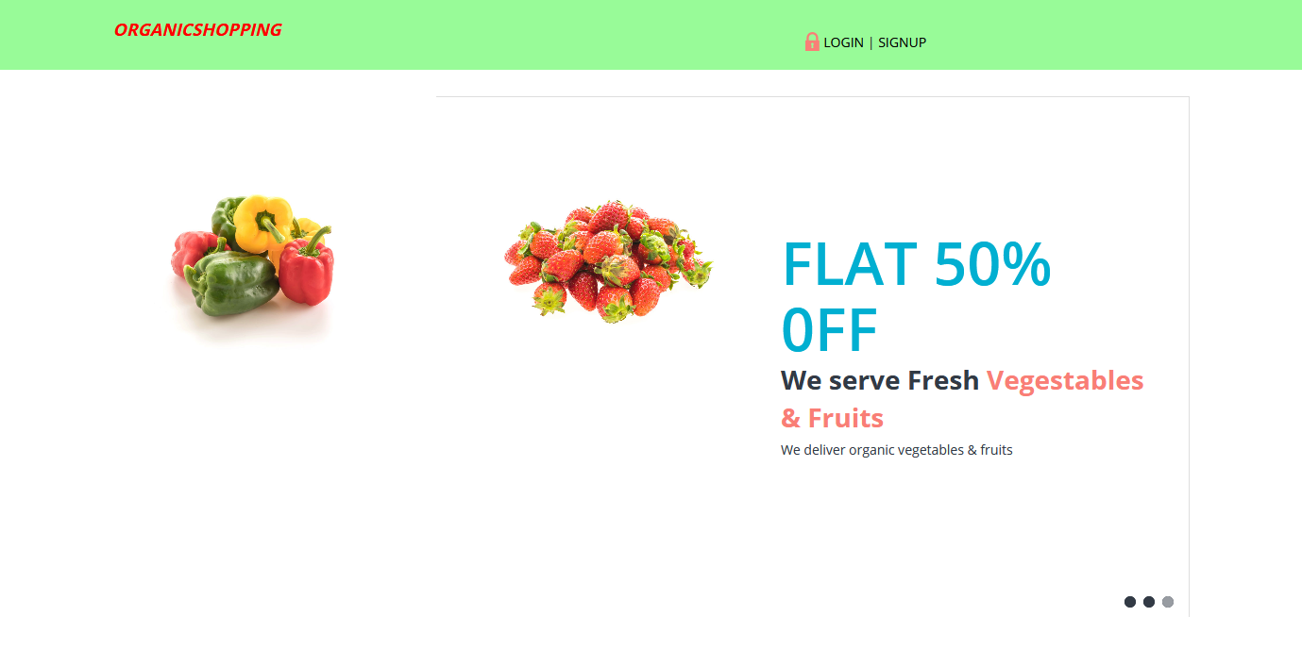

**2. REGISTRATION**

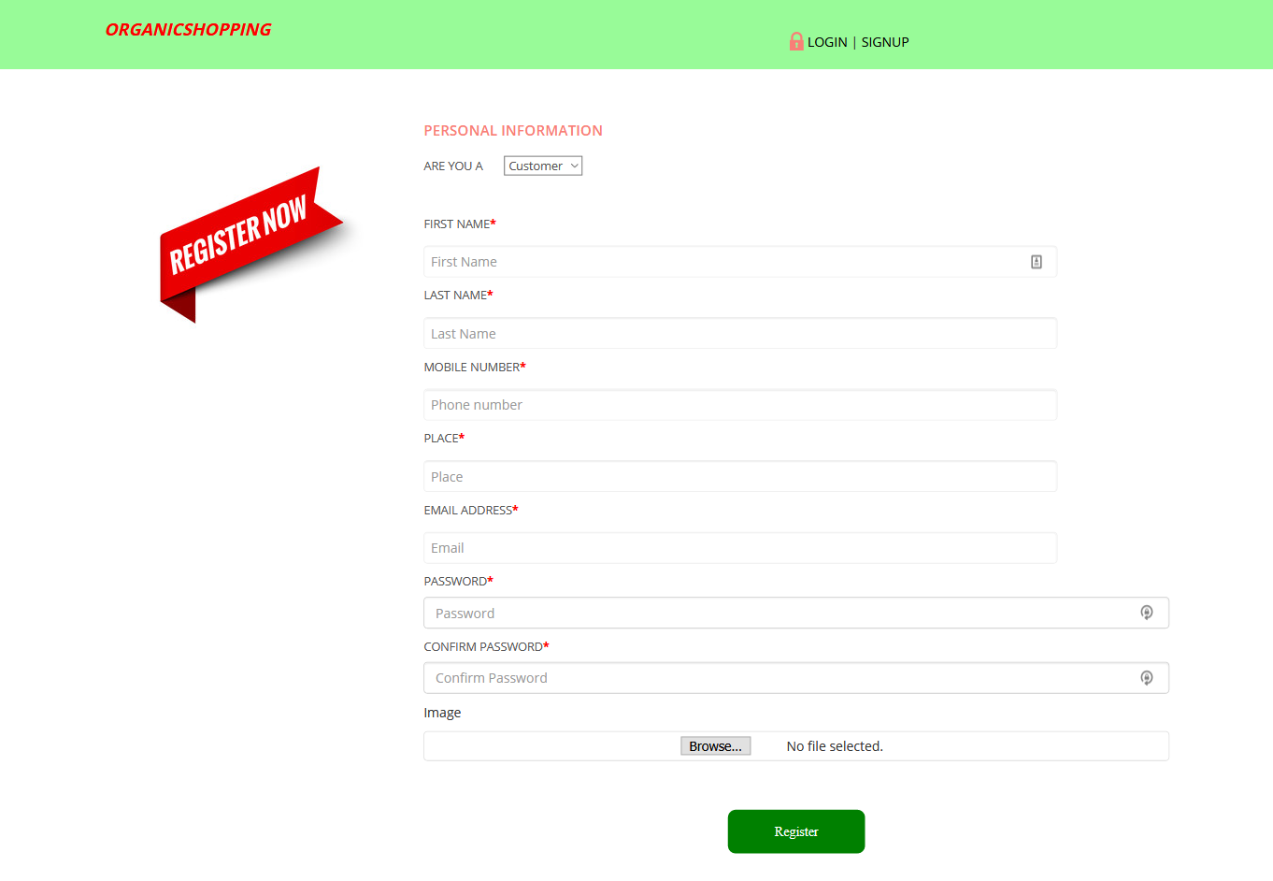

**3. LOGIN**

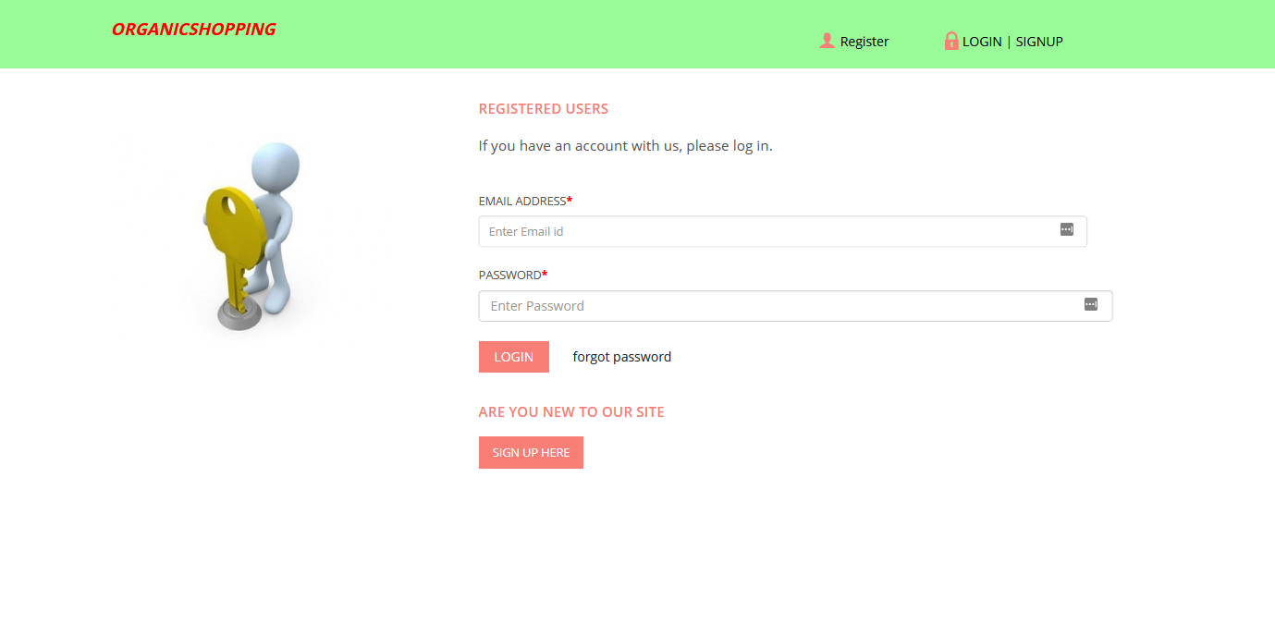

**4.CUSTOMER HOMEPAGE**

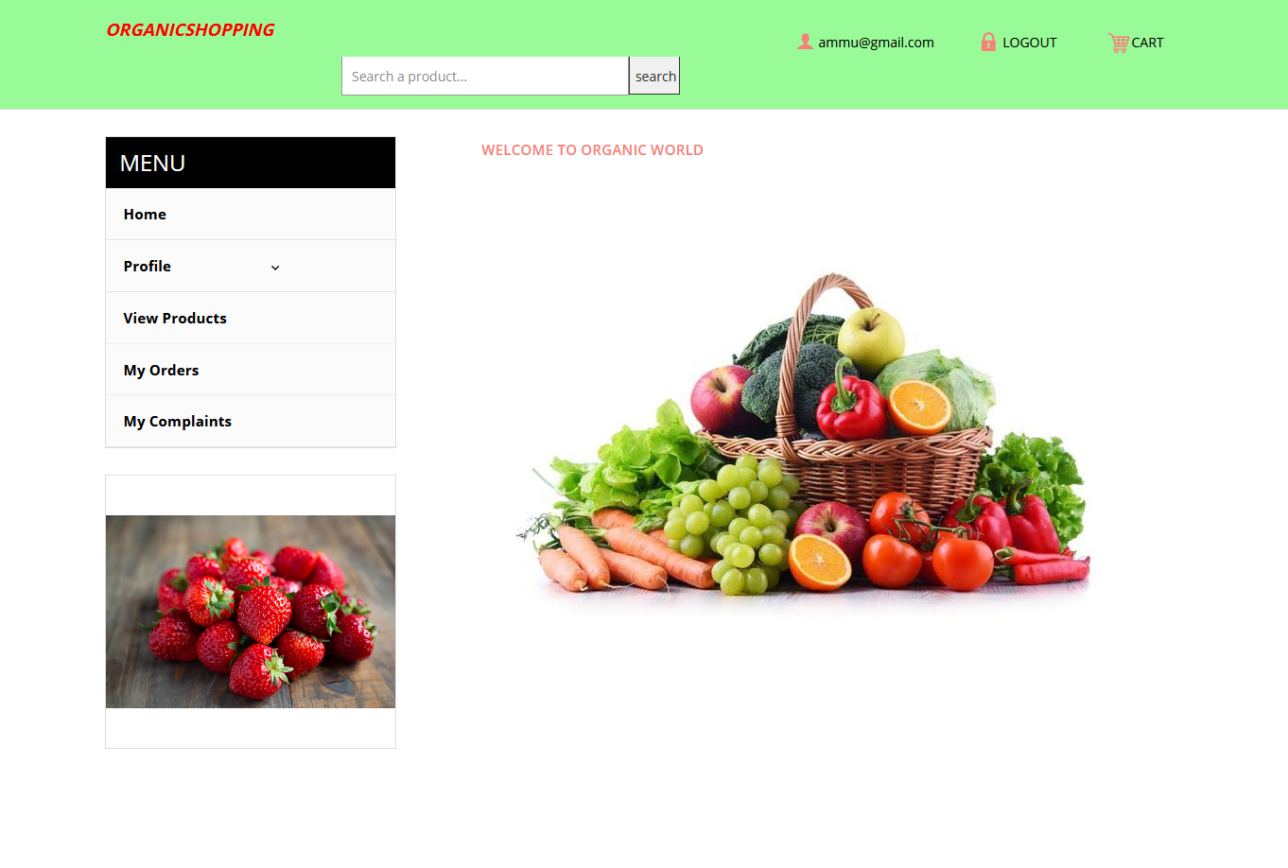

**5.PRODUCTS ON CUSTOMER PAGE**

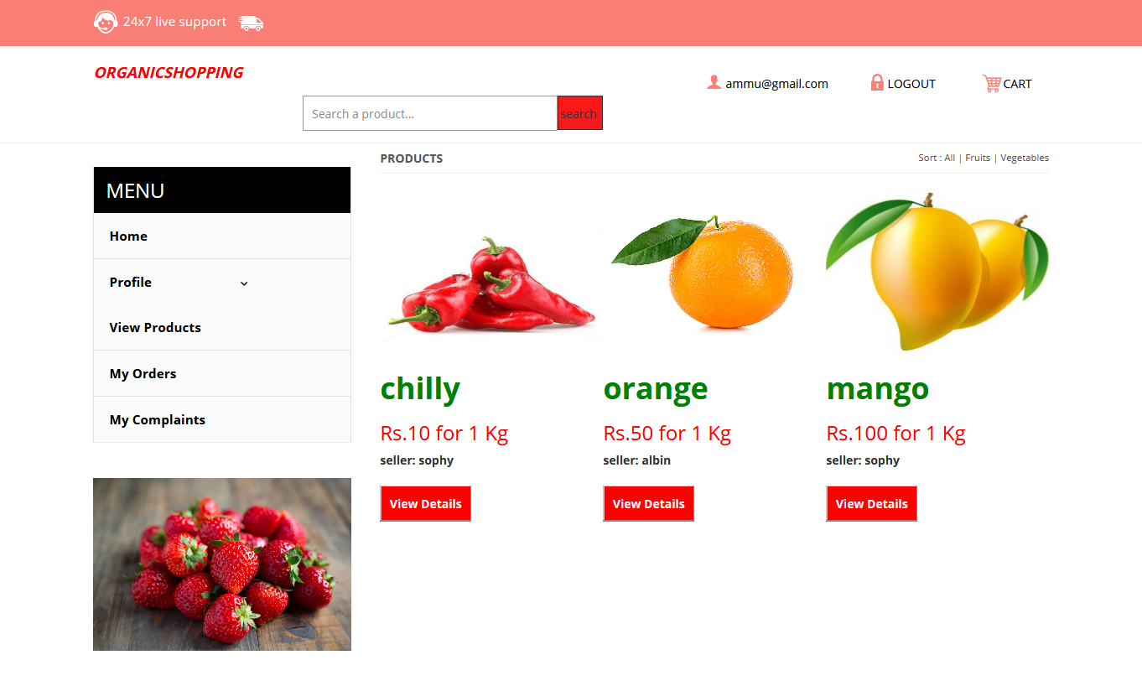

**6. ORDERS OF CUSTOMER**

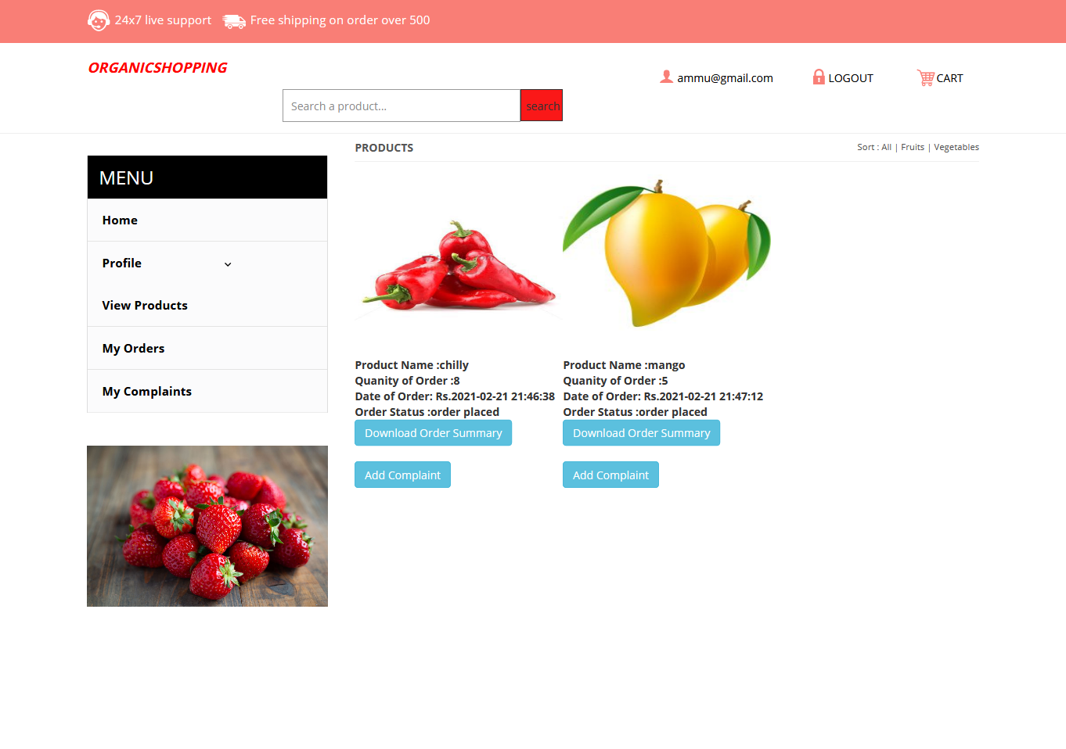

**7. SELLER HOMEPAGE**

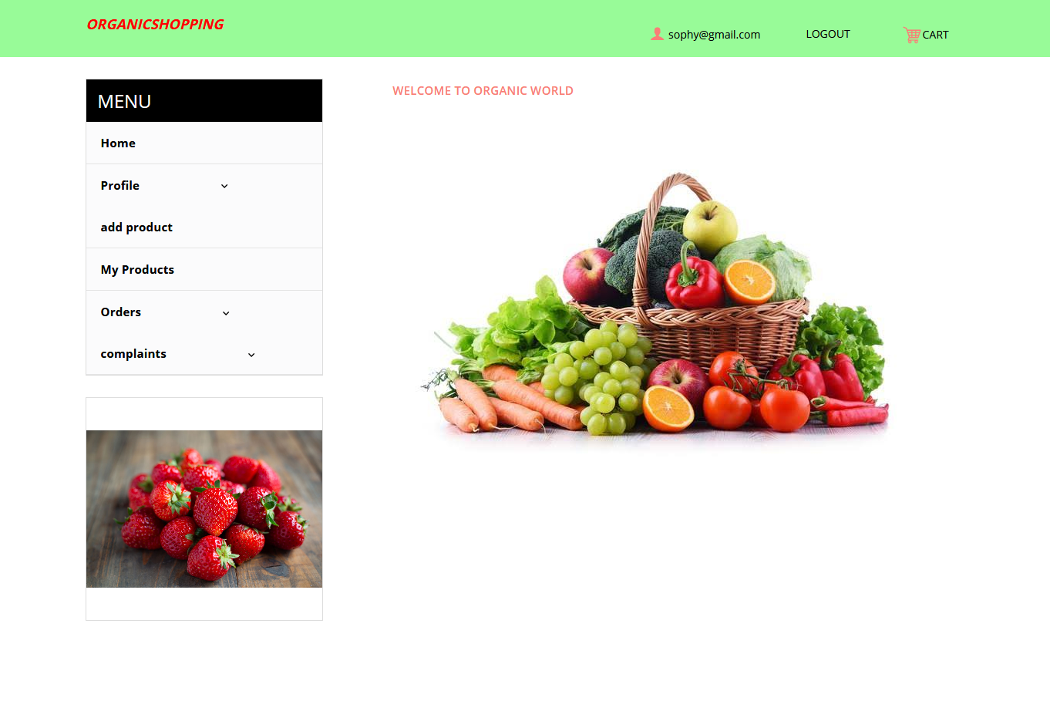

**8.SELLER PRODUCTS**

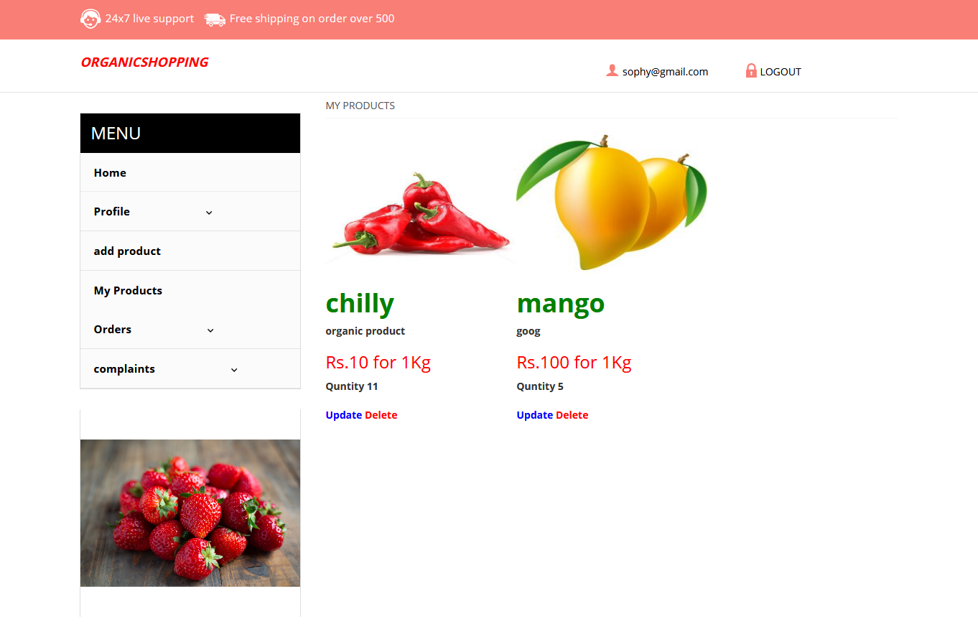

**9.SELLER ADD PRODUCT PAGE**

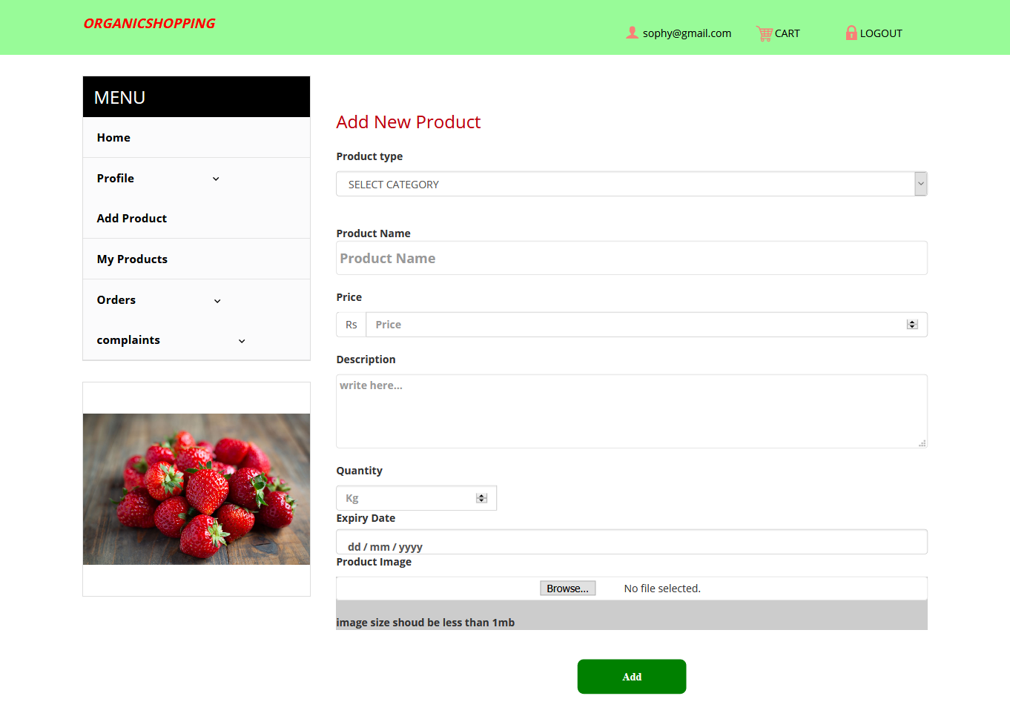**10.ADMIN HOME PAGE**

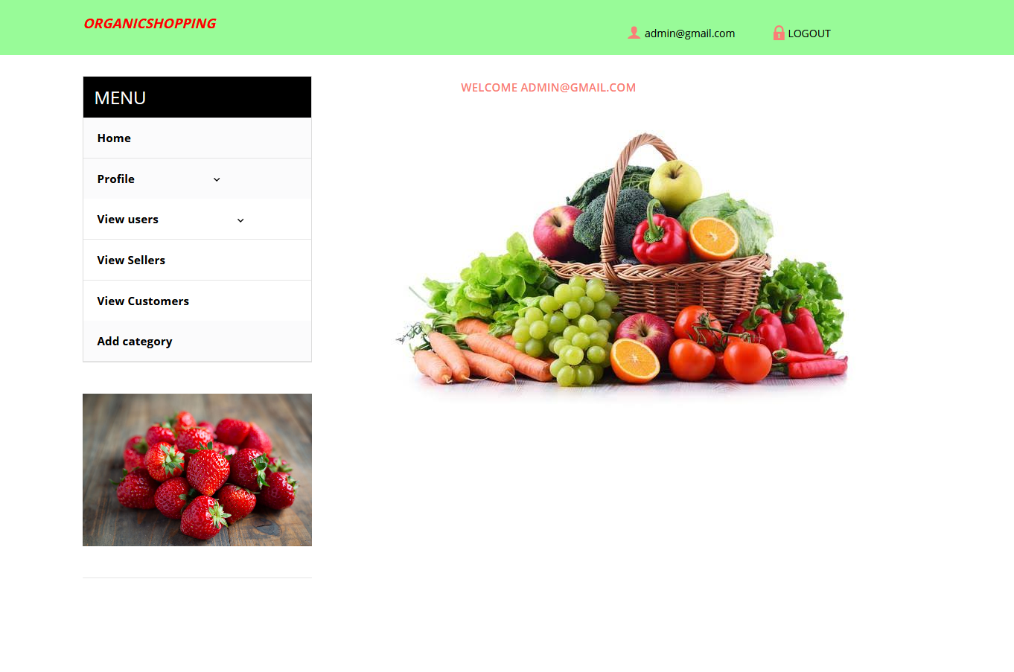

**11. ADMIN VIEW USERS**

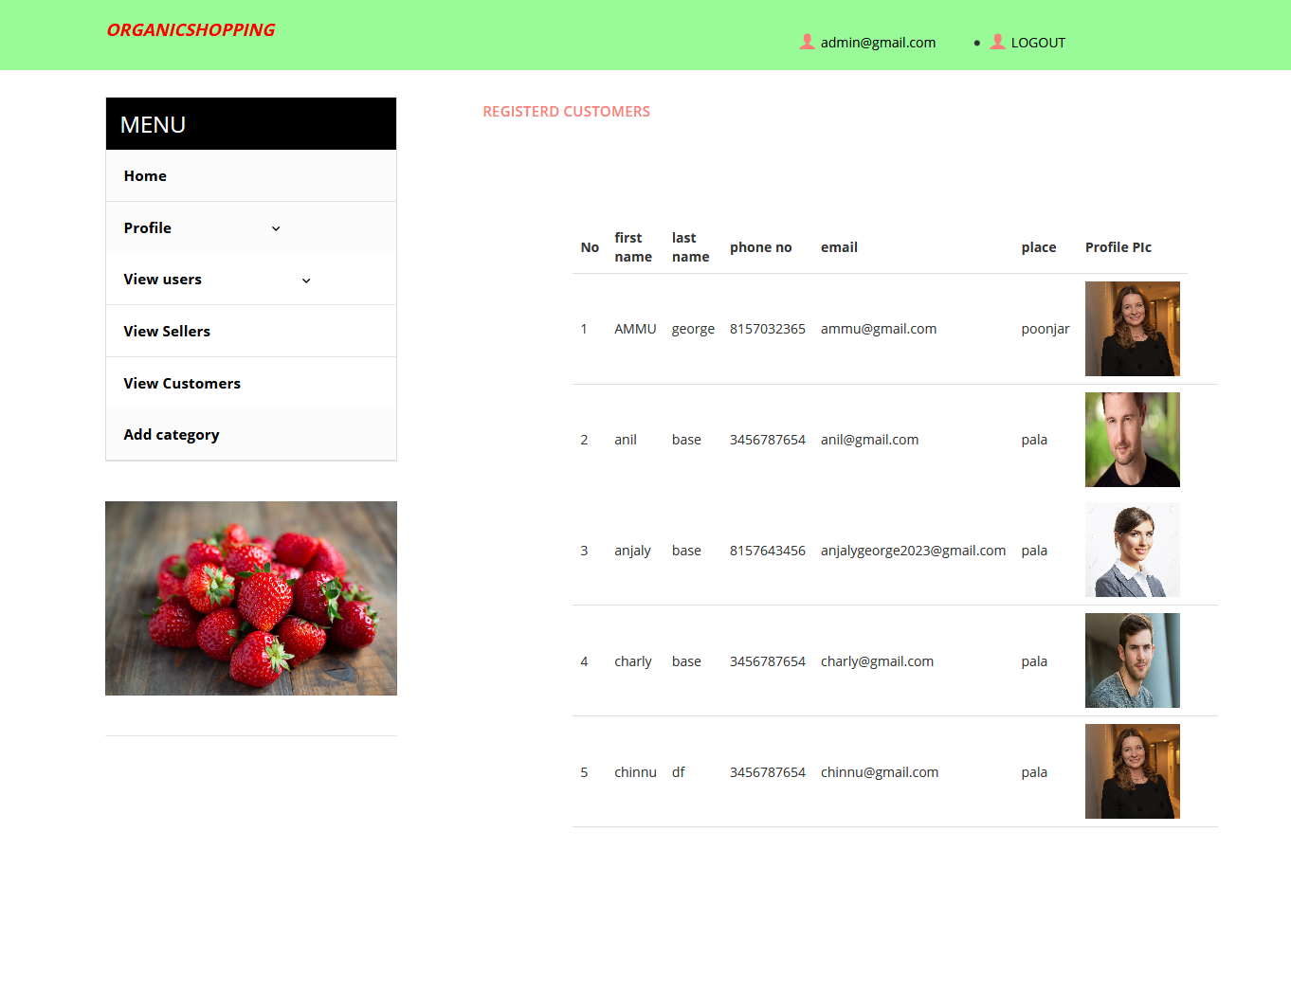

**12. ADMIN ADD CATEGORY PAGE**

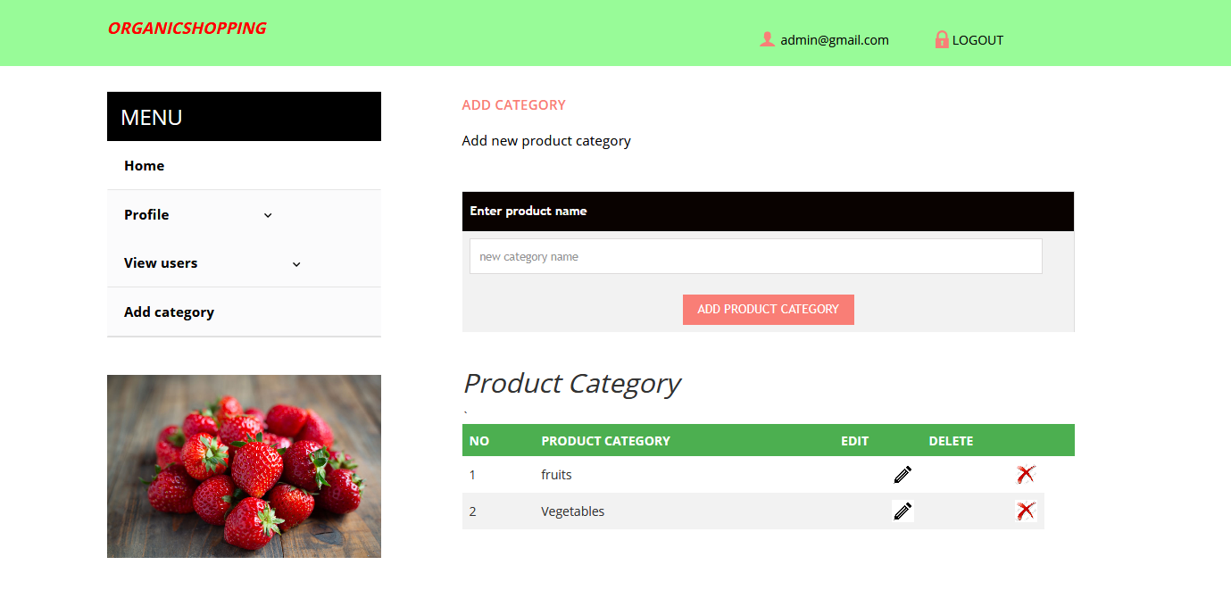

**5.4 TESTING**

It is the process of evaluating a system or its components with the intent to find that whether it satisfies the related requirements. In computer hardware and software development, testing is used at key checkpoints in it’s done with executing the software overall process to identify whether objectives are being met. The process or method of finding errors in a software application or program so that the application functions according to the end user's requirement is called software testing.

Software testing is used to assess the feature of a software item. Testing process ensures the quality of the product. Testing is the process that should be done during the development of software. In other words software testing is a verification and validation process.

**5.4.1 BLACK BOX TESTING**

Black box testing is also called functional testing. It is a software testing method and is used to test the software without knowing the internal structure of code or program. Internal system design is not considered in this type of testing. This type of testing is mainly focus on the software requirements and specifications. In the proposed work black box testing is used for the following requirements:

* Login
* New User Registration
* Edit Details

Advantages of Black Box Testing are:

* The designer and the tester are independent of each other because testing is unbalanced.
* The tester does not need knowledge of any specific programming languages like java ,c++...
* Test is done from the point of view of the user.
* Code access not required

Disadvantages of Black Box Testing are:

* The test can be redundant if the software designer has already run a test case
* Test cases are difficult to design, without having clear functional specifications
* It is difficult to identify all possible inputs in limited testing time. So writing test cases are difficult to design.

##### **5.4.**2 WHITE **BOX** TESTING

White box testing is also known as structural testing and glass box testing. This testing is related to the knowledge of the internal logic of an application’s code. It is also called open box testing. Internal software and code working must be known for this type of testing. Tests are related to the coverage of code statements, branches, paths, conditions. In proposed work white box testing is used for the following requirements:

* Programming code
* Database Accessing

Advantages of White box testing are:

* The testing of the software no need to wait for the GUI
* It helps in optimizing the code
* Beneficent side-effects
* Provide stability and usability of the test cases.
* It helps in removing the extra lines of code, which can bring in hidden defects.
* Is done with executing the software

Disadvantages of white box testing are:

* Expensive
* It takes more time for the tester to develop the test cases.
* Test cases are a waste if changes in the implementation code are done frequently.

**5.4.3 UNIT TESTING**

Unit is the smallest testable part of software. Unit testing is used to validate that individual units of source code are working properly. In object-oriented programming, the smallest unit is a method and it contain a base/super class, abstract class or derived/child class but in procedural programming language a unit may be an individual program, function, procedure, etc., while The main advantage of the unit testing is used to improve the quality of code and save the tester's time and effort.

**5.4.4 SYSTEM TESTING**

System testing is the testing and is used to ensure that by putting the software in different environments it still works. It is done with executing the software system testing the application is working correctly from the point of view of a user. The main purpose of this system testing is to evaluate the system’s compliance with the specified requirements. Whole system is tested as per the requirements. Black-box type testing that is related to overall requirements specifications, covers all combined parts of a system.

##### **5.4.5 USER ACCEPTANCE TESTING**

Acceptance testing is to ensure that the delivered product meets the expectations of the user. It is belongs to the class of black box testing. The goal of acceptance testing is to verify that the software is done with executing the software ready and can be used by the end-users to perform those functions and tasks for the software development. This type of testing is done to verify if system meets the customer specified requirements. User or customers do this testing to determine whether to accept application.

**5.4.6 VALIDATION TESTING**

Validation is the process of evaluating the final software product that correctly identifies the customer expectations and requirements. Validation Testing checks that the product correctly meets the customer needs. This testing can also be defined as to demonstrate that the product fulfils its intended use when deployed on suitable environment. This testing is done with executing the software.

**5.5 TEST CASES**

**Test Case Id :** TC1

**Tests Used :** Black Box Testing/White Box Testing

**Correct Data :**

First Name :Anu

Last Name :Roy

Email :anuroy948@gmail.com

Password :anuroy@123

**Function :** New Seller Login

|  |  |  |  |  |  |
| --- | --- | --- | --- | --- | --- |
| Sl No: | Step | Test Data | Expected Result | Actual Result | Status |
| 1 | Enter correct registration Details And submit | Registration Information | Registered Successfully | Registered Successfully | Success |
| 2 | Enter registration Details And press cancel button | Registration Information | Cancel all details and staying on the same registration page | Cancel all details and staying on the same registration page | Success |
| 3 | Enter email address without gmail mark | Email: anuroy@g.co | Invalid email Id | Invalid email Id | Success |
| 4 | Password and confirm password mismatch. Click Submit button | Password and confirm password mismatch. Click Submit button / cancel button | Password mismatch | Password mismatch | Success |

Table 1: Test Case1

**Test Case Id :** TC2

**Tests Used :** Black Box Testing/White Box Testing

**Correct Data :**  Email- [anuroy948@gmail.com](mailto:anuroy948@gmail.com)

Password: anuroy@123

**Function :** Registered user Login

|  |  |  |  |  |  |
| --- | --- | --- | --- | --- | --- |
| Si No: | Step | Test Data | Expected Result | Actual Result | Status |
| 1 | Enter correct email id and password | email id: [anuroy948@gmail.com](mailto:anuroy948@gmail.com)  password: anuroy@123 | Login Successful | Login Successful | Success |
| 2 | Enter incorrect email id or password | email: [anuroy948@gmail.com](mailto:anuroy948@gmail.com)  password: anuroy@982 | Wrong email id or password | Wrong email id or password | Success |

Table 2: Test Case2

**Test Case No** :TC3

**Tests Used** :Whitebox Testing/Blackbox Testing

**Function** :Edit Details

|  |  |  |  |  |  |
| --- | --- | --- | --- | --- | --- |
| Si No: | Step | Test Data | Expected Result | Actual Result | Status |
| 1 | Edit email id and click save/cancel button | User email id | Message “Successfully Edited” | Message “Successfully Edited” | Success |
| 2 | Edit user name and click save/cancel button | User name | Message “Successfully Edited” | Message “Successfully Edited” | Success |
| 3 | Edit products added by seller and click save/cancel button | Seller product details | Message “Successfully Edited” | Message “Successfully Edited” | Success |
| 4 | Edit user address and click save/cancel button | user Address | Message “Succesfully Edited” | Message “Succesfully Edited” | Success |

Table 4: Test Case3

**Test Case No** :TC4

**Tests Used** :White**box** Testing/Blackbox Testing

**Function** :verify service provider

|  |  |  |  |  |  |
| --- | --- | --- | --- | --- | --- |
| Si No: | Step | Test Data | Expected  Result | Actual Result | Status |
| 1 | Check details and click Go button | registeration details | Add New user to database | Add New user to database | Success |
| 2 | Check details and click Cancel button | registeration details | Delete User | Delete User | Success |

Table 5: Test Case4

**6. CONCLUSION AND FUTURE WORK**

**6.1 CONCLUSION**

In this project first an attempt has been made to find the need of the system to fulfil the needs of a detailed study has been designed in such a way that it is user friendly and easy to use. This particular system has been designed in an attractive manner so that even a user with minimum knowledge can be able to operate the system easily.

The system is developed with scalability in mind. All modules in this have been tested separately and put together to form the system. Finally the system is tested with real data and everything works successfully. Thus the system has fulfilled all the objectives identified and is able to replace existing system. The advantage of this system is that, the package can be easily being incorporated with any other package. In future the package can be developed further to act as virtual manager caring out all the operation. The main objective to develop “Organic Shopping” using PHP and MYSQL project is to overcome the manual errors and make a computerized system

**6.2 FUTURE SCOPE**

* Instant message system can be introduced
* GPS interactive graphical user interface can be implemented
* More effective and powerful for common people/user

**7.BIBLIOGRAPHY**

BOOKS OF REFERENCE

* Marvin R. Gore & John W Stubbe,”Introduction to php”.
* Peter Nortan,”Php and Mysql”.
* K K Agarwal “software engineering”.
* Marvin Gore “elements of system analysis”

WEBSITES

* Wikipidea
* [www.php.net](http://www.php.net)
* www.youtube.com